Github link:

https://github.com/Nagraj-B/Databricks_Assessment/tree/main

above link has 3 branches ( Dev, QA and Main)
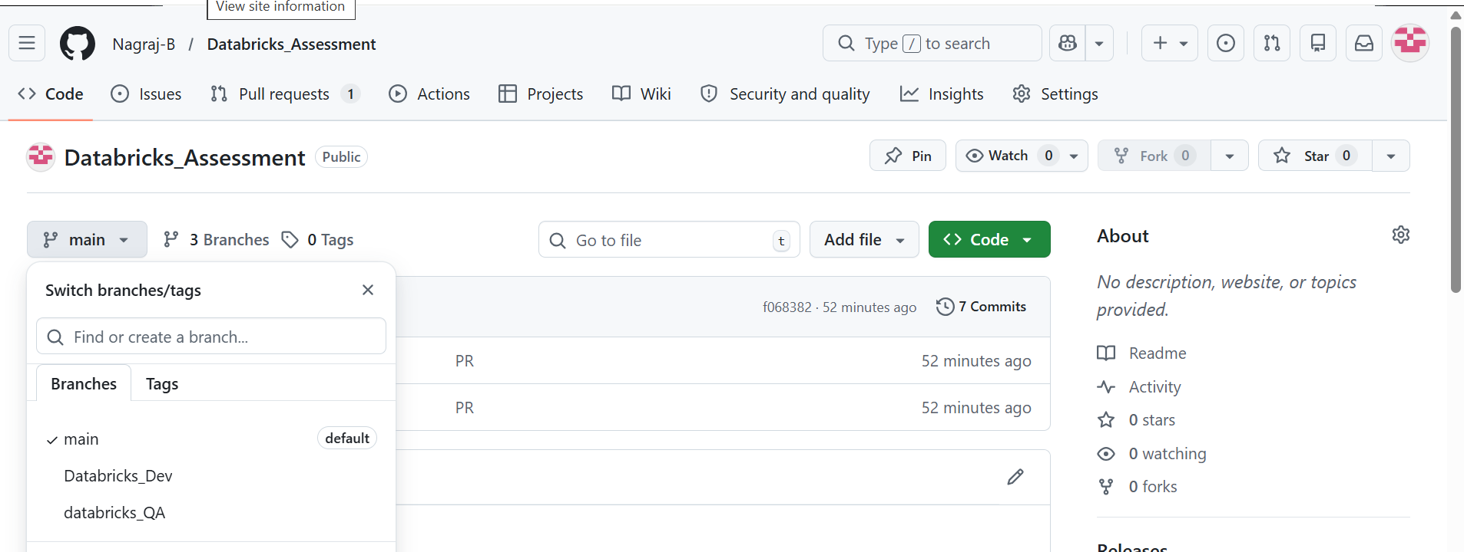

Linked Github folders:
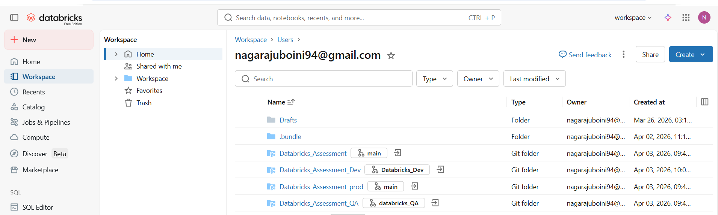

Catalogs:
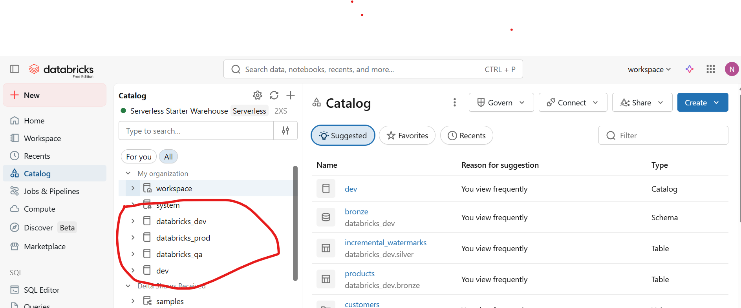

Schemas:
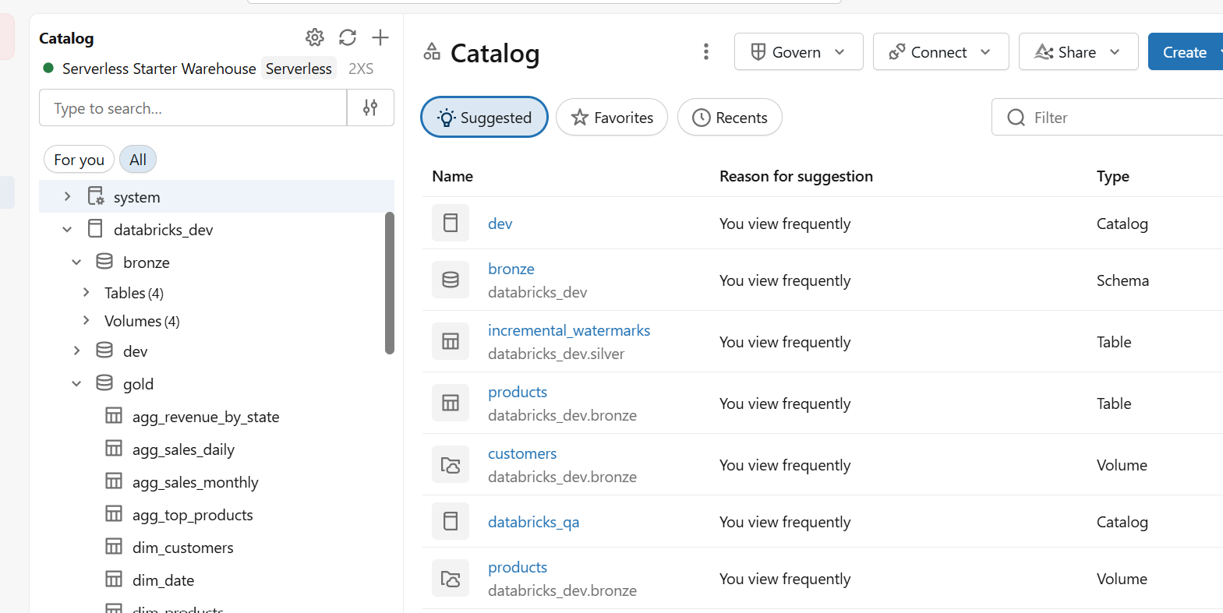

Jobs:

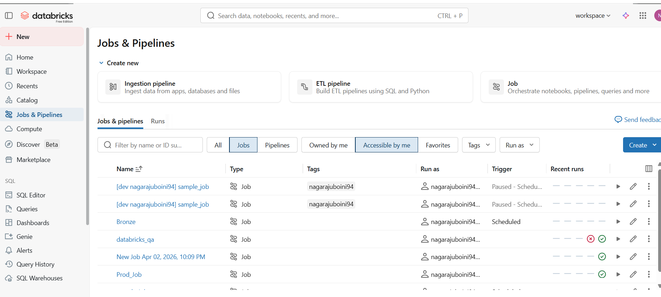

CICD: 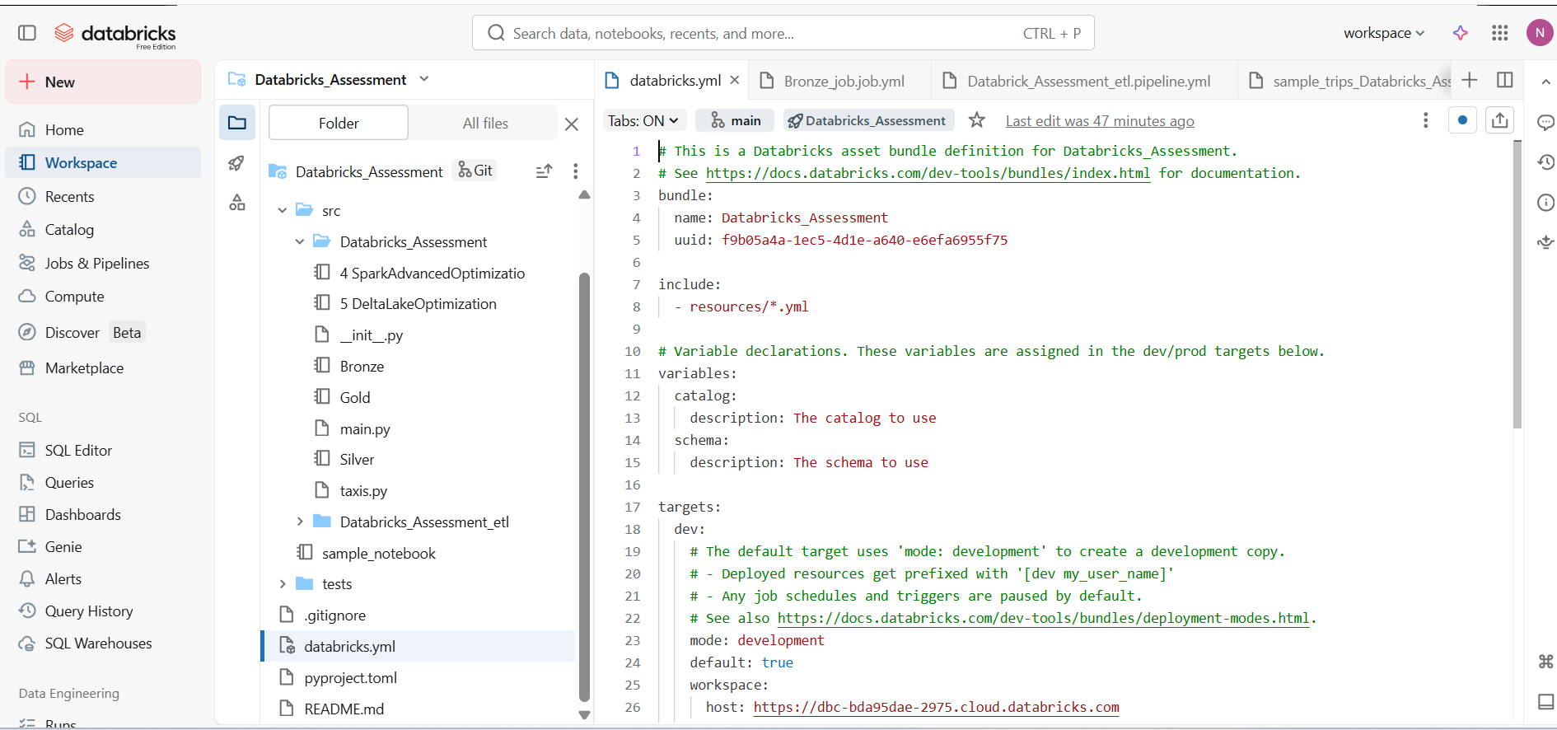

Genie:
